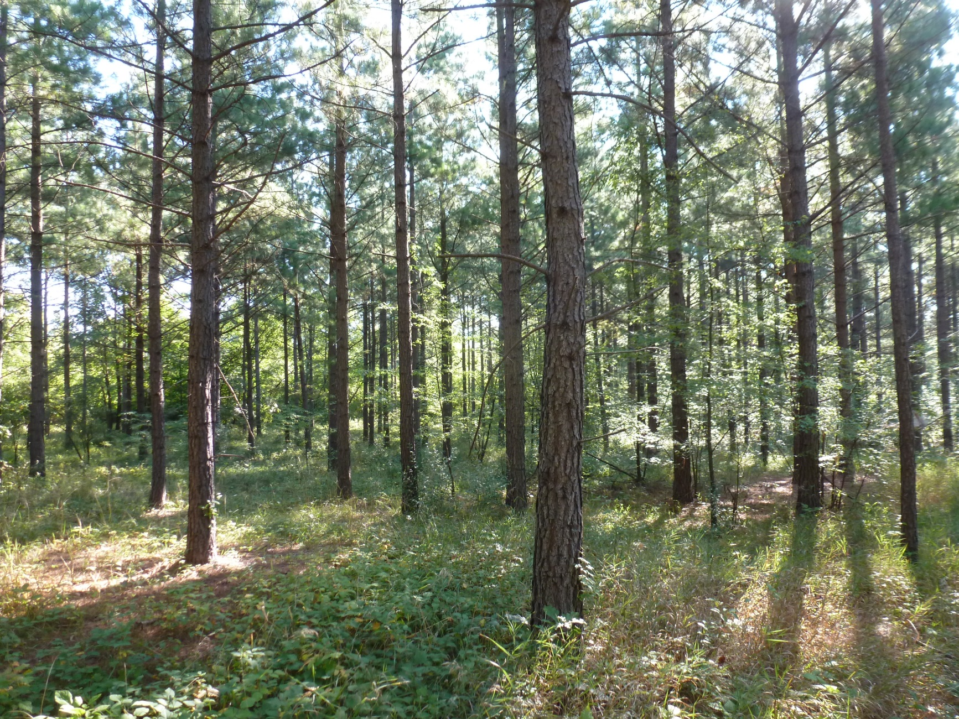

**Young loblolly pine stand**

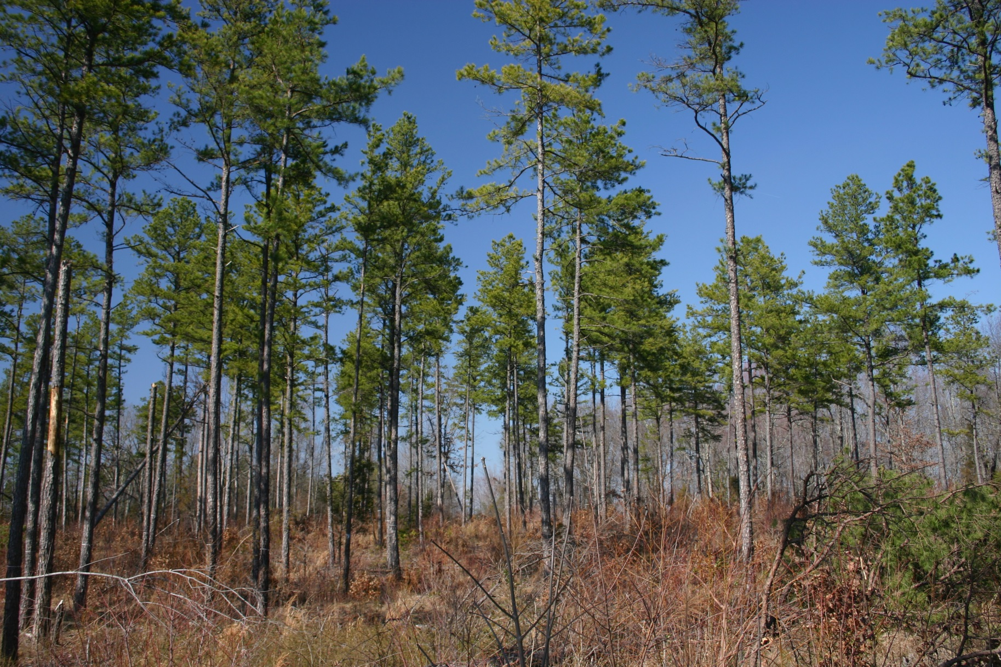

**Mature shortleaf pine stand**

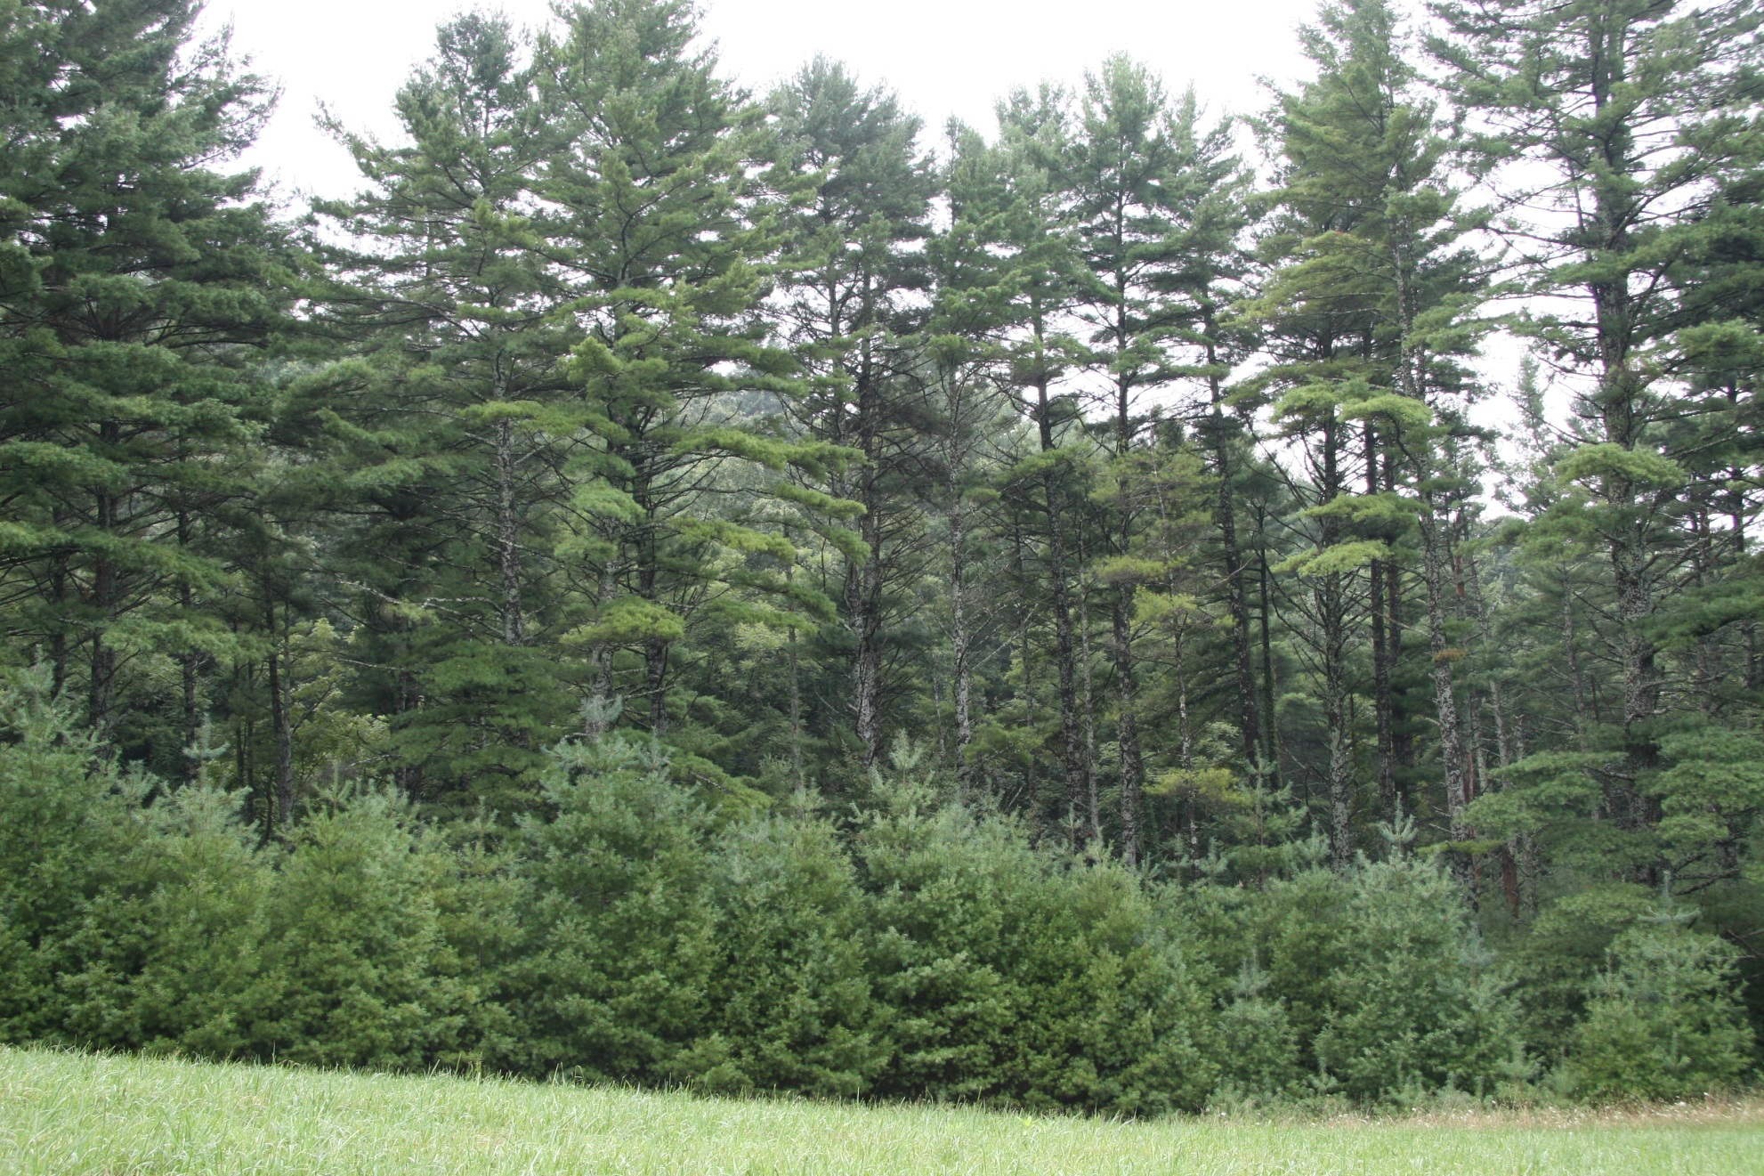

**Mature white pines with young trees on edge**

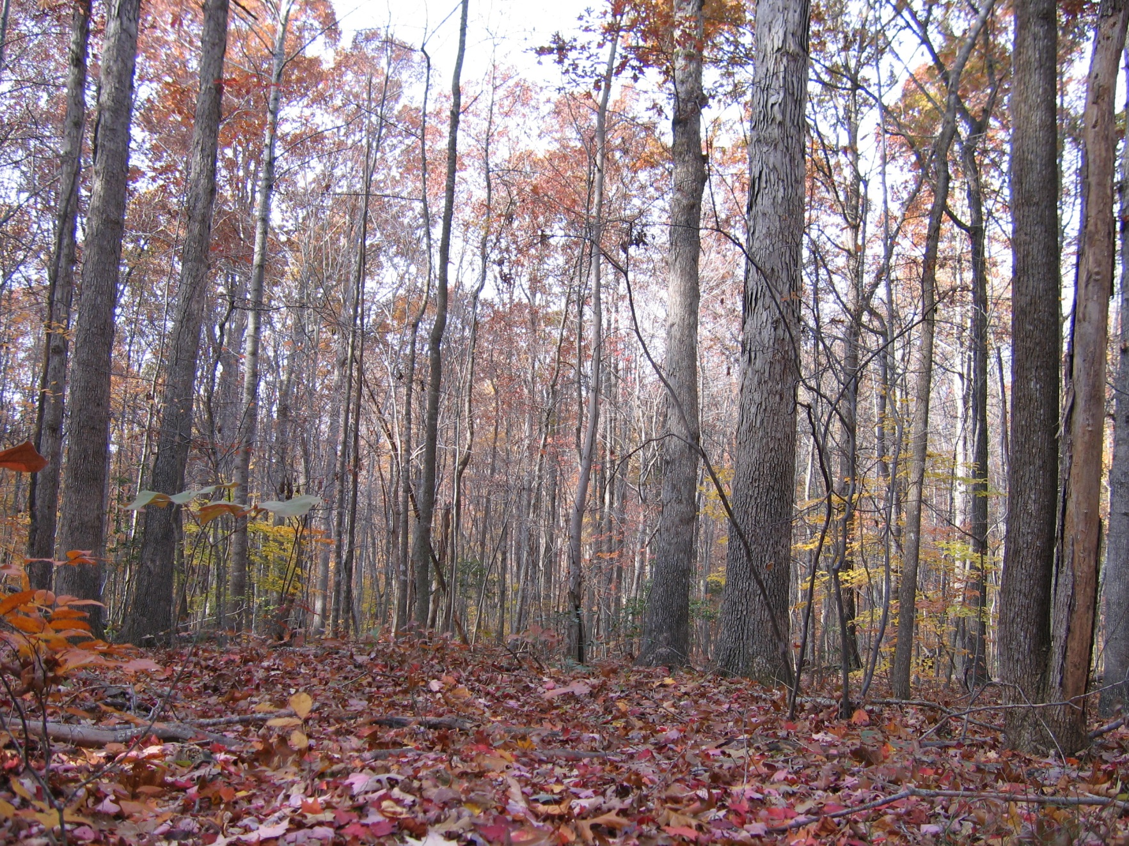

**Oak-hickory forest in fall**

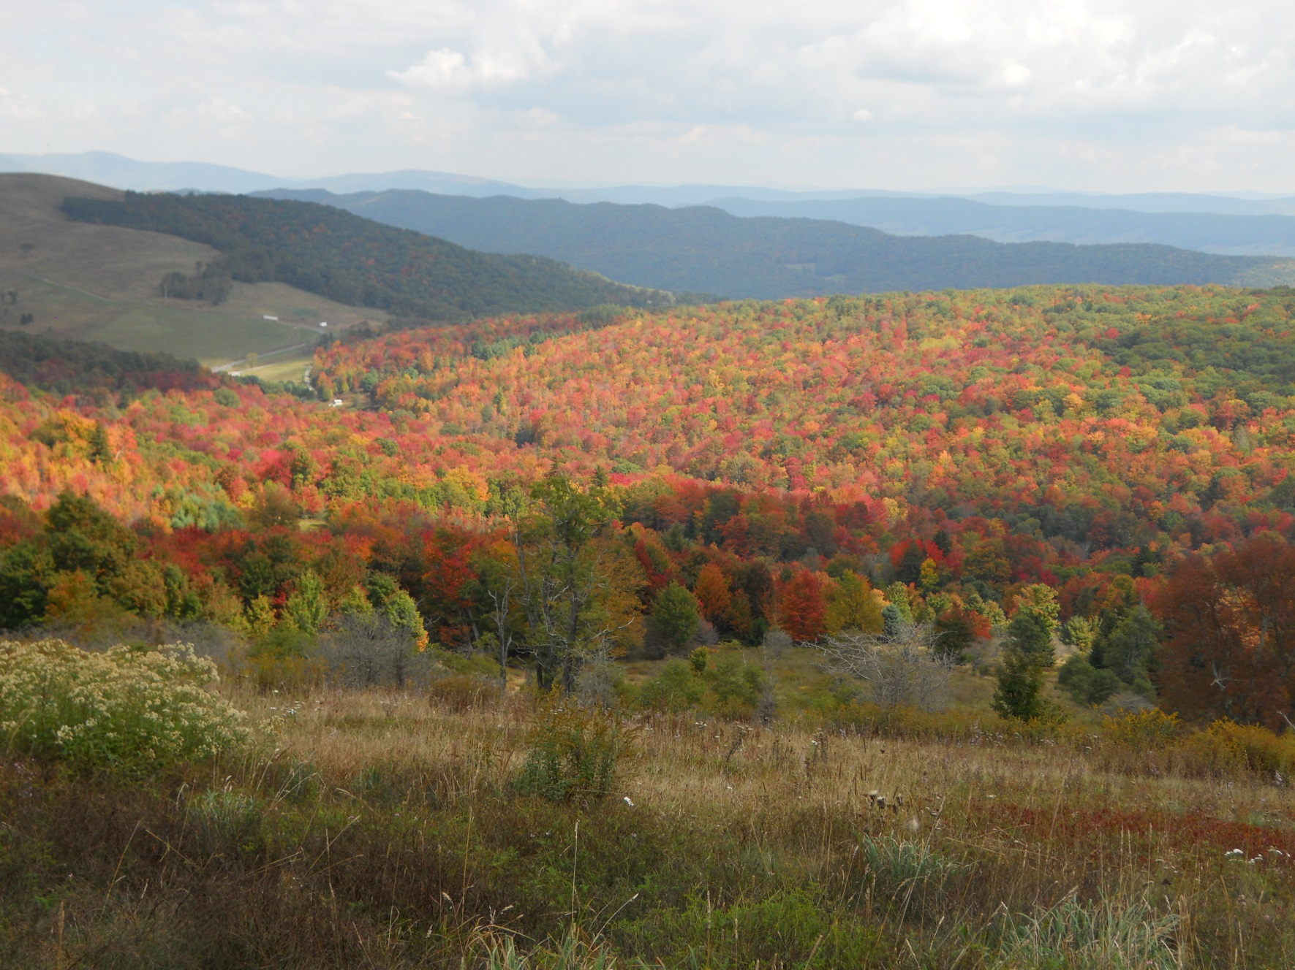

**Beech-birch-maple forest in fall**

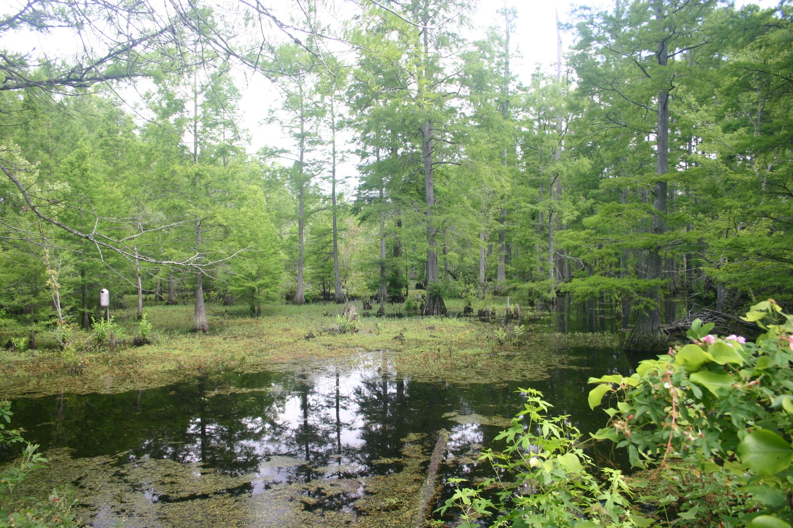

**Cypress swamp forest on river’s edge**