**Threats to Virginia’s Forests**

**Objective:**  Students will use a simulation to understand factors that increase, decrease, or conserve Virginia’s forests.

**Standards of Learning:** Science 6.1, 6.7, 6.9, LS.1, LS.10, LS.11, BIO.8

**Materials:**

Copies of page with Forest Cover and blank Virginia maps (see below)

Dry beans or peas

**Background**

Currently, about 62% of Virginia’s land is forested. A variety of natural and human actions can cause the amount of forest to decrease, increase, or remain the same. Clearing land for agriculture or development changes the land from forest to another use; thus, agriculture and development decrease the amount of forest land. Planting trees or allowing old fields to return to natural forest cover are activities that increase the amount of forest land. Actions that do not change the overall amount of forest land can be said to conserve the amount of forest land. Establishing a State or National Forest is one example of a conservation strategy. Forest management activities may appear to decrease the amount of forested land (immediately after a harvest), but this situation is temporary as a new forest is either planted or established naturally from sprouts or seed. Thus, ongoing forest management conserves forest land.

**Activity:**

Make 3 columns on the board, with the headings “increase”, “conserve”, and “decrease”. Ask students to list some specific things that could happen to increase, decrease, or conserve the amount of forest land in Virginia. Try to list all of their ideas without correcting any. Tell students you will return to this list later.

Give each student or pair a page with 2 maps, one showing total forest cover and one blank Virginia map (see below), and a small handful of dried beans. Each bean will represent one parcel, or piece, of forest land. Students should place beans on areas of their blank map that should be heavily forested, according to the forest cover map. To represent large chunks of unbroken forest, the beans should touch. Students should cover about 2/3 of their map with beans and save the rest for later use.

Pull a scenario from the envelope and read it aloud. Students will add, remove, or leave (conserve) beans in the correct portion of the state, depending on the statement read. Continue reading statements until you have covered a good representation of the types of changes that can occur. You may wish to repeat some of them, changing the details slightly.

**Questions for discussion:**

* Did you have more forests before or after the activity?
* What were some of the ways forests were conserved? Added? Lost?
* Did you have any areas that were once large, unbroken areas of forest, but now have gaps between patches of forest? What are some problems with breaking forests into small patches?
* Looking at the lists we made earlier, would you add or change anything?
* Does harvesting trees lead to a loss of forest land? Why or why not?
* Why do we need forests in our state?
* Does it matter if native forests are replaced by invasive plants? Why or why not?
* Virginia actually loses thousands of acres of forest land each year, through conversion to other uses. What effects could this forest loss have?
* How can we balance our need for developed areas, such as neighborhoods and shopping areas, with our need for forests?

*Lesson plan developed by Ellen Powell, Virginia Dept. of Forestry*

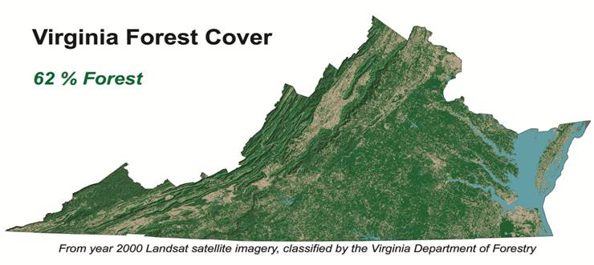**Action Statements for Instructor’s Use**

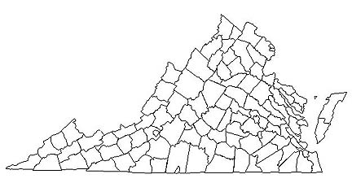

Landowners in eastern Virginia harvest their loblolly pine stands and replant young pine seedlings. Conserve 12 forest parcels.

Developers remove all the trees from land to make way for new home subdivisions in central Virginia. Remove 8 forest parcels.

Landowners in southwestern Virginia find a market for medicinal plants that grow on the forest floor. The income they receive allows them to keep their land instead of selling it to developers. Conserve 5 forest parcels.

An invasive insect that kills oak trees is found in a large northern Virginia park and spreads quickly through the park and surrounding city. Remove 2 forest parcels.

Wildfire burns its way through acres of forest land in western Virginia. After the fire, invasive species of plants move in to cover the disturbed area. Remove 4 forest parcels.

Gypsy moth caterpillars defoliate a part of the George Washington National Forest for several years in a row, killing most of the oaks. Remove 3 forest parcels.

Schoolchildren across the state plant trees for Arbor Day. Add 5 forest parcels.

Farmers in south central Virginia stop mowing some of their pastures and allow trees to seed in naturally. Add 6 forest parcels.

Scout troops plant hardwood trees along miles of creek, to create riparian buffers. Add 4 forest parcels.

Asian bittersweet invades forest land in Shenandoah National Park, overtopping trees and breaking branches with its heavy vines. Remove 2 forest parcels.

Landowners in northeastern Virginia use good forest health practices, such as monitoring and thinning, to prevent outbreaks of southern pine beetle that might damage their pine forests. Conserve 7 forest parcels.

Several counties in eastern Virginia approve permits for new shopping centers. Remove 5 forest parcels.

Landowners in southwestern Virginia establish conservation easements on parts of their property. Conserve 6 forest parcels.

A citizen deeds his forest land in southeastern Virginia to the state, to be managed as a new State Forest. Conserve 2 forest parcels.

The US Forest Service purchases some farmland to add to the Jefferson National Forest, and begins planting new trees. Add 3 forest parcels.

A city in central Virginia starts a program to increase its amount of forest cover. Add 2 forest parcels.

Homeowners plant trees around their homes to save energy by shading their homes in the summer. Add 2 forest parcels.

Landowners in central Virginia cut their hardwood stands, allowing the stumps to sprout into new trees. Later they remove competing trees to allow the strongest saplings to grow freely. Conserve 5 forest parcels.