What Grows Where?

Objective

Students will compare maps and speculate why different forest types occur where they do.

Standards of Learning: Science 6.1, 6.7, 6.9, LS.1, LS.6, LS.9, ES.1, BIO.1, BIO.8
(Also 4.5 and 4.9, but lesson is designed for grades 6+)

Materials

Virginia Forest Cover Types map
Printouts of Virginia’s physiographic regions map and forest land assessment map (see last page of lesson)
Worksheet with questions (you may add additional questions)

Activity

Have students read the forest types background information. Assign students to groups of 2-4. Give each group a worksheet and 3 maps: a page-sized version of the forest types map, the physiographic regions map, and the forest land assessment map. (The latter two can be printed on one page).

Each group will complete a worksheet about forest types in Virginia. Groups should closely examine the forest types map, using the other maps and background information to help answer the questions. *Remind students that each map has its own key and shows different information. The colors do not mean the same thing on the different maps!

When groups have finished, use the worksheets as a basis for discussion of forest types and other land cover.

Lesson Plan Developed by Ellen Powell, Virginia Dept. of Forestry
What Grows Where? Forest Types Worksheet

Before you begin, read the Forest Types Background Information.

Part I. - Compare the forest types map with the physiographic regions map to answer these questions.

- List the forest type(s) found in each region.

Coastal Plain ____________________________________________________

Piedmont _______________________________________________________

Blue Ridge ______________________________________________________

Ridge and Valley __________________________________________________

Appalachian Plateau________________________________________________

- What factors might cause the differences in forest types from east to west in Virginia?
___________________________________________________________________

___________________________________________________________________

- Why do you think the following forest types are concentrated in distinct areas?

Oak-gum-cypress _________________________________________________

Maple-beech-birch _________________________________________________

White pine _______________________________________________________

- Which forest type is in your area? _________________________________________

- Which of the types shown is rarest in VA? Why do you think that is true?
______________________________________________________________________

______________________________________________________________________

Part II. Look at the Virginia Forest Land Assessment map to answer these questions.

- What are some examples of non-forested areas? ______________________________

_____________________________________________________________________

- Where do you see the largest concentrations of non-forested areas? ______________

_____________________________________________________________________
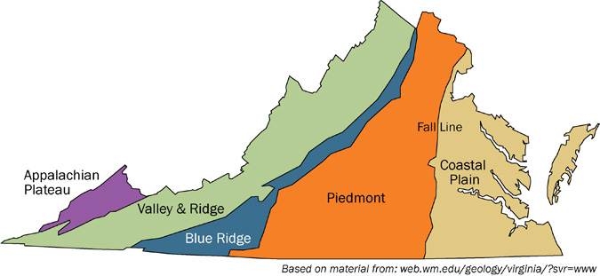
Virginia’s Physiographic Regions

