Could I Live Here?

Objective:

Students will learn about native wildlife and decide whether certain species could live on a site.

Standards of Learning:

Science 3.6, 3.10, 4.5, LS.4, LS.10, LS.12

Materials:

Laminated cards with information (optional – mount cards on back of wildlife pictures)
Clothespins

Background:

Wildlife habitat must include food, water, shelter, and space. For each wildlife species, the amount and type of food, water shelter, and space are different. Thus, there is no one habitat that is best for all wildlife species. Some animals are habitat generalists that can live in many different areas. Others are specialists, needing exact conditions in order to survive.

In this activity, students will learn the habitat requirements for particular species, and decide whether an area of the State Forest would likely be part of the habitat for that species.

In the Forest:

During your trail walk, stop at an area of your choosing, preferably one near a stream or other water source. Designate some boundaries to students. (For example, to the top of the hill in one direction, to the far edge of the stream in another direction, to the road in another direction, and so on. Make the area as large or small as you like.) Pair students up and give each pair a card and clothespin. Each pair will read their card together, then explore within the boundaries you have set, to decide whether their animal could live in that habitat. (They should consider mainly food, water, and shelter, and not worry about space requirements for this exercise.) If they think the animal would likely live in this area of the forest, they should pick a particular spot that would attract the animal and use the clothespin to attach the card where it can be easily seen. If the animal is not likely to live in this area, they should keep their card with them.

Bring the group together and take a “hike” around the area. When you come to a card, ask the pair to share their reasons for clipping the card there. Pairs whose animal would not live in the area should show their card and report why not, and what would need to change about the habitat in order to attract this animal. Have students collect and return all cards before you go inside.

Questions for Review and Discussion

- What are the important features of any habitat? (Food, water, shelter, space)
- Do all animals need the same kind of habitat? Why or why not? (No, different requirements for the above features)
- What kinds of animals count as wildlife? (It depends on who you ask. To some people it includes insects and spiders. To others, it means birds and mammals. To still others, it means those species that can be hunted. To some, it means only native species, while for others it can include pigeons and other exotic species. There is no exact answer here.)
- What are some general characteristics of animals that can live in this type of habitat we are in? (Answers will vary depending on where you stopped.)
- Would your animal have enough space on the State Forest to live? (Depends on species. In general, larger animals need more space – sometimes hundreds or thousands of acres – whereas some small animals might be able to live on just an acre or two. Space needs, and even habitat type, also can change with season for some animals – e.g. migratory birds.)
- What are some things we could do to make this area more suitable for more kinds of wildlife? (Add specific components of habitat – many examples; e.g., change human uses of this area or nearby areas. Remove other hazards or deterrents that might be keeping animals away.)
- What can you do at home to make your yard a better wildlife habitat? (See above – look for specific examples.)
- Are there reasons people might not want to attract wildlife to certain areas? (Damage to landscaping, fear of harm to pets or self, messy droppings, etc.)

Black-crowned Night Heron (Nycticorax nycticorax)

Habitat: Streams, lakes, marshes

Food: Fish, amphibians, insects, small mammals, and young birds

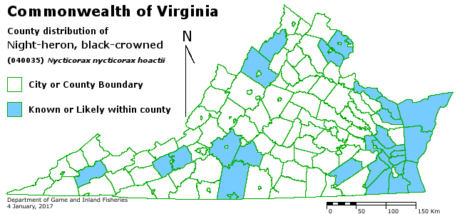

Northern Saw-whet Owl (Aegolius acadicus)

Habitat: Evergreen or mixed forests

Food: Mice, voles, chipmunks, insects

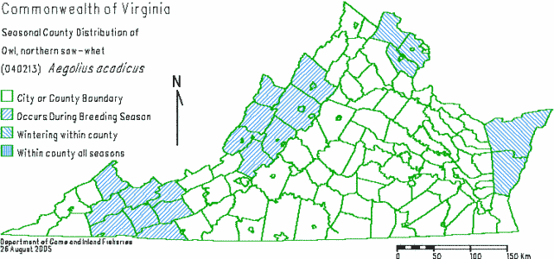
Northern Bobwhite (Colinus virginianus)

Habitat: Open woods, old fields, farmland

Food: seeds, grains, fruits, soft plant parts, insects

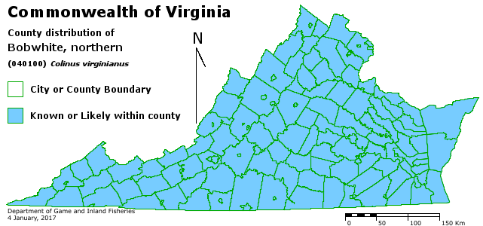

Cedar Waxwing (Bombycilla cedrorum)

Habitat: Open parks, orchards, residential areas

Food: Fruits, berries, insects

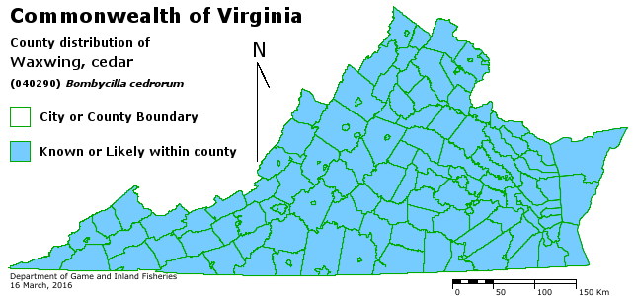
Carolina Chickadee (Poecile carolinensis)

Habitat: Deciduous woods, residential areas

Food: Seeds, berries, insects

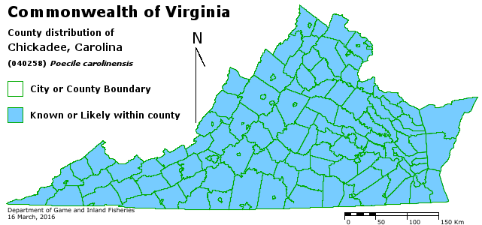

White-tailed Deer (Odocoileus virginianus)

Habitat: Mixed woodlands, woods near farmland, openings and young forests close to mature forests

Food: Soft and woody plant parts, fruits, fungi, acorns, field crops

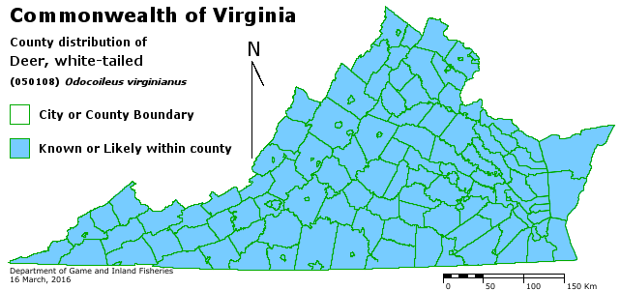

Wild Turkey (Meleagris gallopavo)

Habitat: Open woods, edges, swamps

Food: Seeds, nuts, acorns, grains, soft plant parts, insects

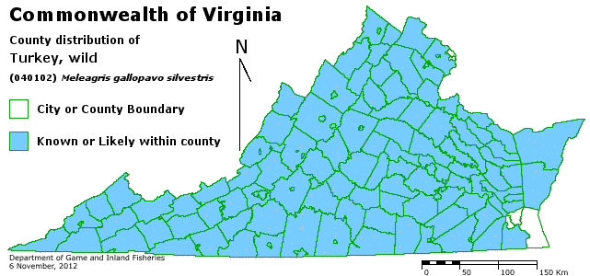

Tree Swallow (Tachycineta bicolor)

Habitat: Open lands near woods, with water nearby

Food: Insects, some berries
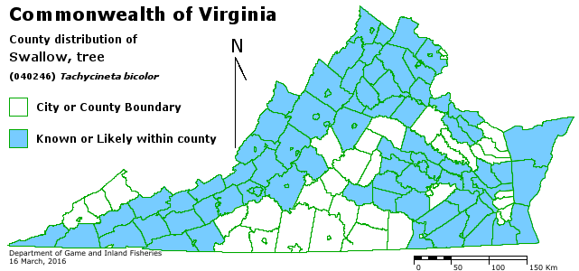

Northern Cardinal (Cardinalis cardinalis)

Habitat: Shrubby edges of woods, brushy areas, residential areas

Food: Seeds, berries, fruits, insects

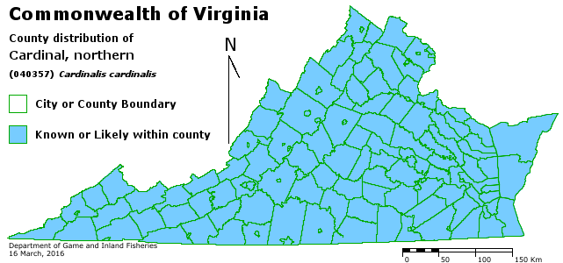

Beaver (Castor canadensis)

Habitat: Rivers, streams, swamps, lakes, ponds, marshes

Food: herbaceous (soft) plants, bark and twigs of woody plants

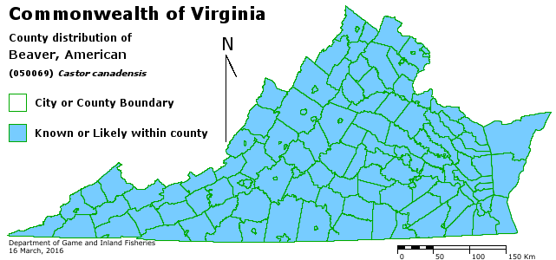
Southern Two-Lined Salamander (Eurycea cirrigera)

Habitat: Under logs or leaves on forest floor of swamps and hardwood forests

Food: Tiny insects, spiders, and other invertebrates

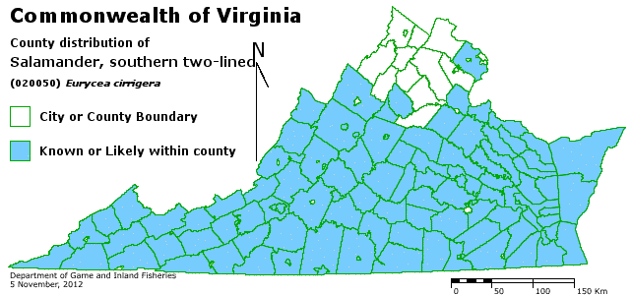

Ruffed Grouse (Bonasa umbellus)

Habitat: Young forests for most activities; nest in deep woodland cover; western Virginia

Food: Insects, berries and other fruits, seeds, acorns

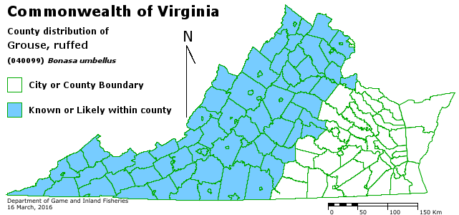

Bald Eagle (Haleaetus leucocephalus)

Habitat: Coastlines and edges of lakes and large rivers

Food: Fish, birds, carrion, occasionally small mammals

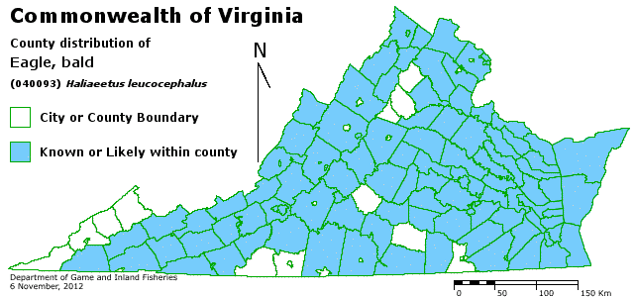

Gray Fox (Urocyon cinereoargenteus)

Habitat: Woods and brushy areas

Food: Small mammals, birds, insects, fruits and berries

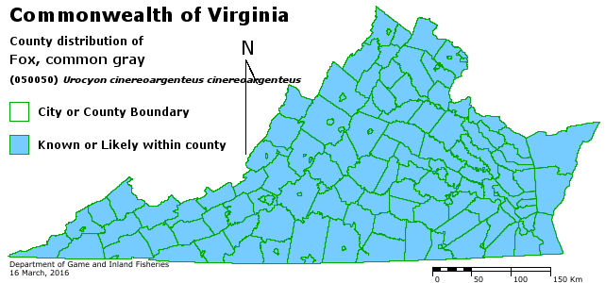

Northern Pintail (Anas acuta)

Habitat: Winter (only time present in VA) – coastal bays, lakes, farm fields

Food: Aquatic plants, some crustaceans, grains

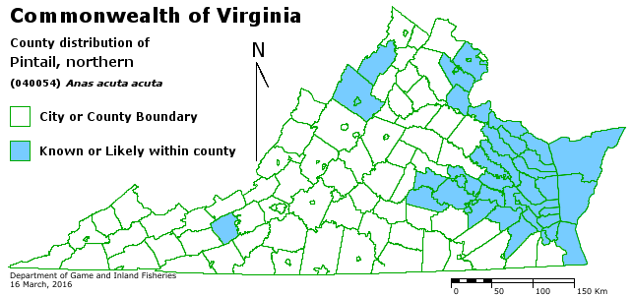

Black Bear (Ursus americanus)

Habitat: Forests and swamps

Food: Insects, carrion, acorns, nuts, fruits, berries, grasses, small mammals, amphibians

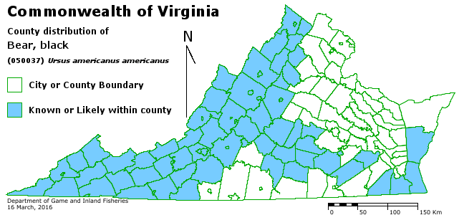
Green Treefrog (Hyla cinerea)

Habitat: Ponds, lake and swamp edges, seasonally flooded areas, and sometimes backyards

Food: Small insects, spiders, and other invertebrates

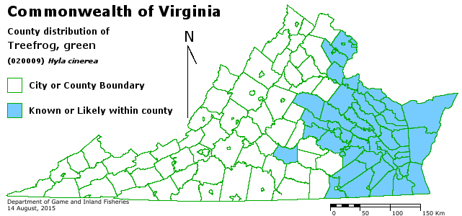

Largemouth Bass (Micropterus salmoides)

Habitat: Pools and backwaters of small to large streams, swamps, ponds, lakes and reservoirs

Food: Fish, crayfish, frogs, insects (small insects and plankton when young)

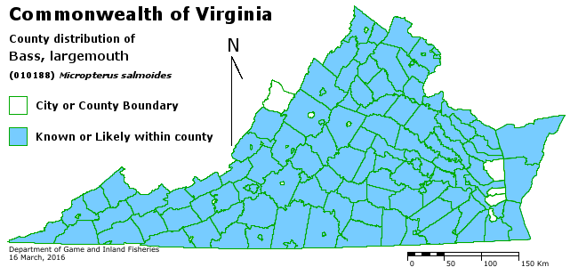
Brook Trout (Salvelinus fontinalis)

Habitat: Clear, cold streams with pools and riffles and gravel or rocky bottoms

Food: Insects and insect larvae, some small fish and crayfish (small insects and plankton when young)

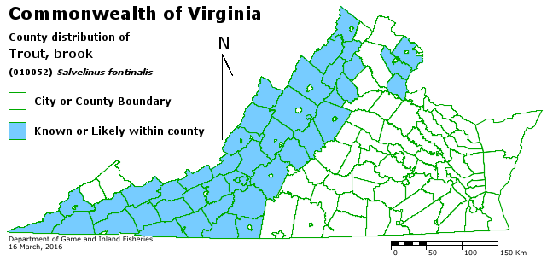

River Otter (Lontra canadensis)

Habitat: In and around large rivers, lakes, marshes, and other wetlands

Food: Mostly slow-moving fish, crayfish, large insects

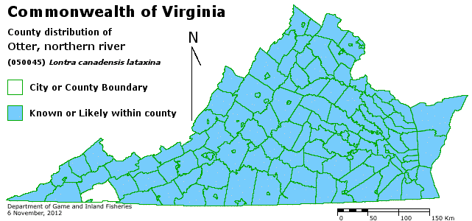
Eastern Cottontail (Sylvilagus floridanus)

Habitat: Thickets and brushy areas, wood edges, meadows

Food: Grasses and other soft plants, tree buds and branch tips

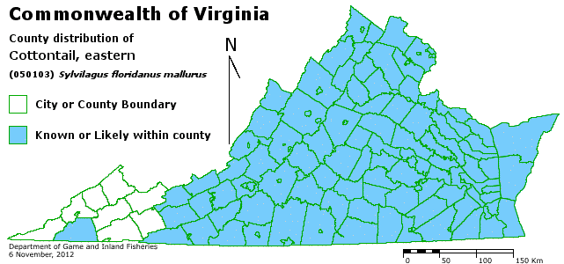

Spring Peeper (Pseudacris crucifer)

Habitat: Woods near swamps, ponds, and seasonally flooded areas

Food: Small insects

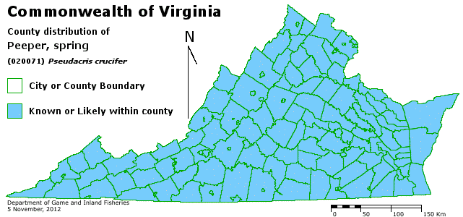
Southern Flying Squirrel (Glaucomys volans)

Habitat: Deciduous forests

Food: Acorns, nuts, seeds, berries, some insects

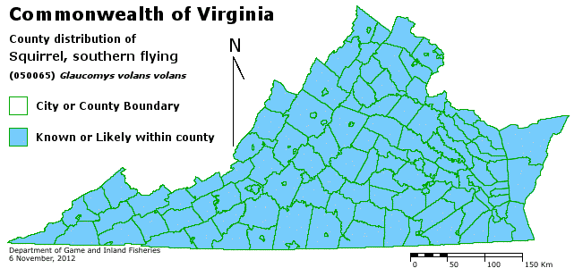

Virginia Opossum (Didelphis virginiana)

Habitat: Open woods with streams, farmland, residential areas

Food: Fruits, berries, grain, carrion, insects, reptiles

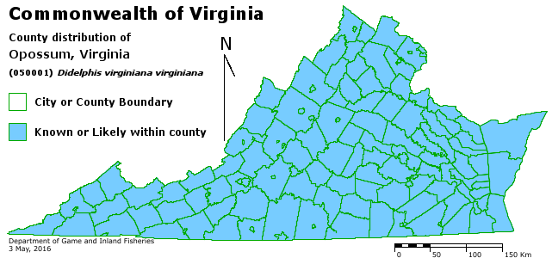
Raccoon (Procyon lotor)

Habitat: Swamps, marshes, forests, parks, and residential areas with water source nearby

Food: Fruits, berries, nuts, insects, crayfish, frogs, eggs, garbage

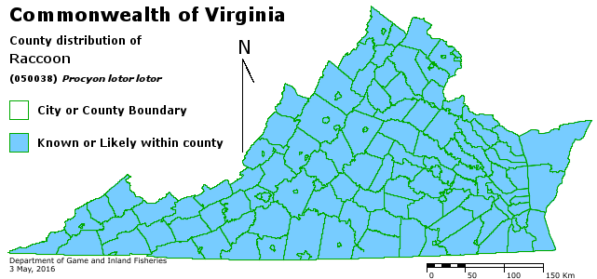

Gray Squirrel (Sciurus carolinensis)

Habitat: Forests, parks, and residential areas with large trees

Food: Nuts, seeds, buds, occasional insects

