Pests Gone Wild

Objective:

Students learn about invasive species issues affecting Virginia’s forests; search the forest for invasive plants; brainstorm and research solutions to invasive species problems.

Standards of Learning:

Science 6.1, 6.7, 6.9, LS.8, LS.10, LS.11, BIO.1, BIO.8

Materials:

- Pests Gone Wild card set
- Invasive plant photos

Background:
A non-native plant or animal is one that was not present in this area before European settlement. Some non-native species, such as honeybees, apple trees, and crop plants, are beneficial to people and have not caused problems in the environment. But some species have become invasive, which means they are capable of causing economic, health-related, or environmental harm.
Invasive species can have many negative effects in an ecosystem. These include:
- Upsetting the natural balance of interactions in an ecosystem, such as food webs, hydrology, soil chemistry, or natural fire regimes
- Competing with, displacing, or causing declines in native species
- Attacking or serving as carriers for diseases that attack native species
- Reducing the overall biodiversity of plants and animals in an area

Invasive species often have special characteristics that allow them to flourish:
- Rapid and prolific reproduction
- Few or no natural predators or diseases to keep them in check in a new area
- Traits which limit competition from other species, such as production of toxic chemicals, aggressive behavior, or an ability to outgrow other species.

Humans have directly caused or enabled the introduction and spread of invasive species. In part, this happened because no one expected what effects a new species introduction would have. The ease of worldwide travel has also enabled species to spread, usually by accident.

To slow the spread of invasives, everyone can take the following steps:
- Learn to recognize invasive species in your area.
- Never plant any species known to be invasive.
- Avoid moving seeds or plant parts into new areas – either purposely, by picking them, or accidentally, on your shoes or clothing.
- Never release non-native animals, such as aquarium fish or other pets, into the wild.
- Get rid of invasive species on your property. You can contact your local Extension office or check university and government websites for information on how to remove problem species.
- Spread the word! Teach others what you know, and encourage them to take action.

In the Forest (or Schoolyard):

Part 1
Introduce the concept of invasive species, using the background information above. Review some of the problems that can be caused by invasive species. Students will now learn more about some species that threaten Virginia’s forests.
Cut apart the cards below so that species name, problem, and source are separate. Mix these up and give each student one card. Ask them to find the two other card-holders who complete their species information. This will sort the class into teams of three. (If you have fewer than 30 students, remove cards 3 at a time, by species. For class numbers not divisible by 3, you can pair up a couple of students with one card to yield a team of 4, or give one student both problem and source cards for a species, to make a team of 2.) When all students are correctly sorted into teams, ask the groups to brainstorm ways they might prevent or resolve problems with their species, based on information they read on their cards. Give teams time to share their recommendations with the rest of the class.

Part 2
Give each team of three a laminated card showing an invasive plant. Choose an area of the forest that borders an open area (where many invasives are likely to be found). Ask teams to search the area for plants that look like their picture. If any are found, discuss what should be done about them.

Back in the Classroom:

Part 1
As a follow-up, have teams research their invasive species. Where is this species currently a problem in our state? What is currently being done to fix the problem? What can the average person do to help? What are the potential environmental, economic, or health impacts if nothing is done?

Part 2
If invasive plants were found on the forest, the class may wish to write a class email to the Department of Forestry to let them know where on the forest this plant was found. (Email stateforest@dof.virginia.gov and put the name of the forest in the subject line.)
The photo cards used on your field trip show some of Virginia’s most common invasive plants. Some have been established here for so long that many people don’t realize they don’t belong here. Search your schoolyard (especially woods edges, fence lines, and unmowed areas) for these invasive plants. If you find any, organize a class workday to remove them, or recommend a course of action to school officials if the problem is extensive.

SPECIES | PROBLEM | SOURCE
Kudzu (Pueraria montana) | This plant grows very fast and tends to grow over objects. It can quickly outcompete native plants by crowding and shading them, and it can affect timber and agricultural production. | It was brought from Japan and planted for erosion control. It was also used for livestock feed, and the vines were used to make baskets.
Garlic mustard (Alliaria petiolaria) | This plant produces many seeds and a chemical which prevents most other plants from growing near it. It can quickly dominate the forest ground cover, preventing the growth of native herbs and tree seedlings. | It was brought from Europe for use in medicines and as a food plant.
Tree-of-heaven  (Ailanthus altissima) | This tree spreads by wind-blown seeds and by root sprouts. It produces a chemical that prevents most other trees from growing nearby. It rapidly fills in forest openings and edges, crowding out native trees. | It was brought from Asia and planted as a pretty ornamental tree that could grow in poor soil and city conditions.
Chestnut blight (Cryphonectria parasitica) | This fungus has changed the composition of entire forests. It attacks a native tree which was once valued for its timber and wildlife food. The fungus kills all but the roots; trees continue to sprout but are killed back while they are still young. | A related Asian species of the tree served as a carrier of this disease.
Gypsy moth (Lymantria dispar) | Its caterpillars can eat all the leaves on large trees, including many valuable timber and wildlife food trees. Repeated defoliation eventually kills the trees. | Native to Europe and Asia, it was originally imported to study its potential for silk production. Humans often move it accidentally when it hitches a ride on firewood, vehicles, or camping gear.
Hemlock woolly adelgid (Adelges tsugae) | This tiny insect sucks sap and injects toxins into the needles of a native evergreen, eventually killing the tree. Loss of this tree changes the makeup of natural communities in our mountains and may lead to an increase in stream temperatures and erosion. | The insect is believed to have arrived accidentally on trees from Asia.
Emerald ash borer (Agrilus planipennis) | This insect feeds on the inner bark of a native deciduous tree, eventually killing it. The affected tree is important economically and as a part of natural communities. | It probably arrived here in wood packing material on cargo ships from Asia. Moving wood from infected trees to new locations has increased the spread of the insect.
Multiflora Rose  (Rosa multiflora) | This thorny shrub sprouts from roots and from seeds spread by birds. The plants can take over forest edges and fields, growing thickly enough to outcompete native plants and restrict wildlife movement. | Native to Asia, it was introduced as a rootstock for grafting ornamental roses. It was also planted in pastures as a “living fence” to keep livestock in or out of areas.
Oriental bittersweet  (Celastrus orbiculatus) | Birds spread the seeds of this fast-growing vine. It can quickly overtop large trees, shading them out. Vines can encircle and girdle tree trunks and can break branches with their weight. | It was introduced from China as an ornamental vine with attractive seed pods. It is often still used for making wreaths.
Wild Pig  (Sus scrofa) | These mammals feed on all types of plant material, earthworms, and small animals. They compete for food with native wildlife. Their rooting behavior disturbs soil, destroys plant communities, and prevents establishment of new plants. | These mammals arrived with the first European settlers, who raised them for food.
Tree-of-Heaven (Ailanthus altissima)
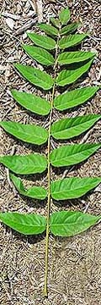
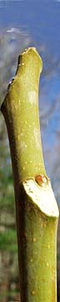
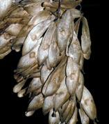
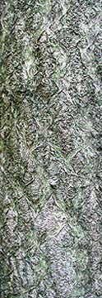
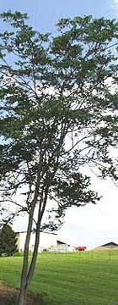
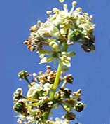

Photos used with permission of Virginia Tech College of Natural Resources and Environment

Autumn Olive (Elaeagnus umbellata)
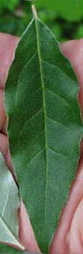
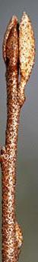
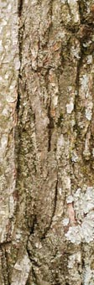
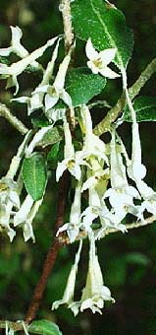
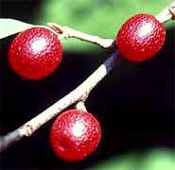
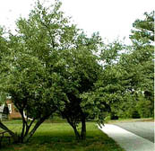

Photos used with permission of Virginia Tech College of Natural Resources and Environment
English Ivy (Hedera helix)

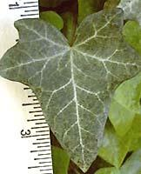 | 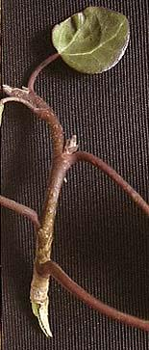 | 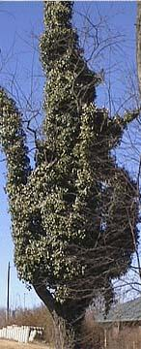 | 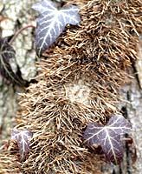
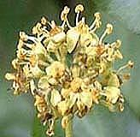 |  |  | 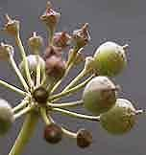

Photos used with permission of Virginia Tech College of Natural Resources and Environment

Oriental Bittersweet (Celastrus orbiculatus)

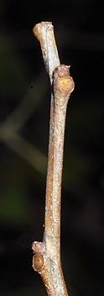 | 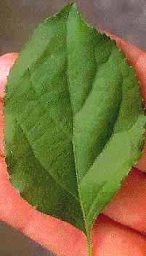 | 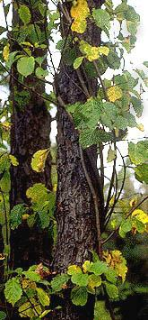 | 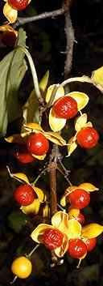

Photos used with permission of Virginia Tech College of Natural Resources and Environment
Japanese Honeysuckle (Lonicera japonica)

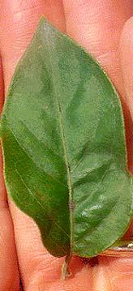 | 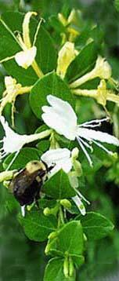 | 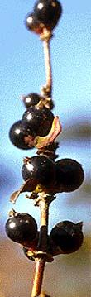 | 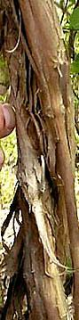 | 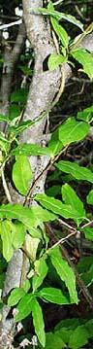

Photos used with permission of Virginia Tech College of Natural Resources and Environment

Multiflora Rose (Rosa multiflora)

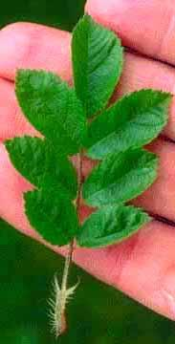 | 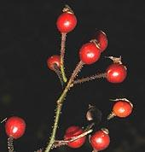 | 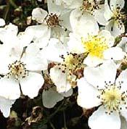
 | 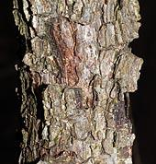 | 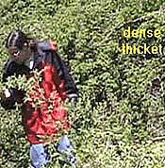

Photos used with permission of Virginia Tech College of Natural Resources and Environment
Royal Paulownia (Paulownia tomentosa)

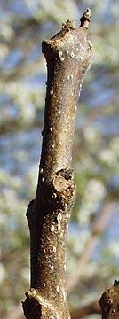 | 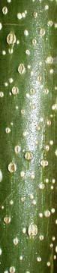 |  | 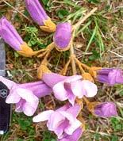 | 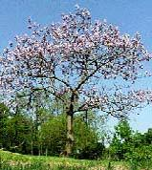
 |  |  | 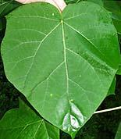 | 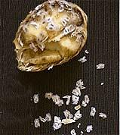

Photos used with permission of Virginia Tech College of Natural Resources and Environment

Mimosa (Albizia julibrissin)

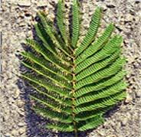 | 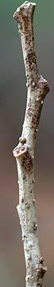 | 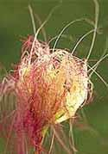 | 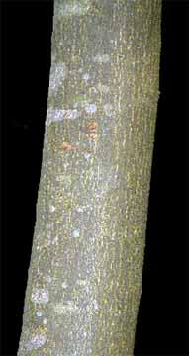
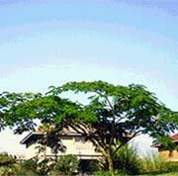

Photos used with permission of Virginia Tech College of Natural Resources and Environment
Kudzu (Pueraria montana)

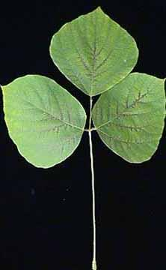 | 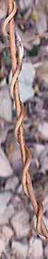 | 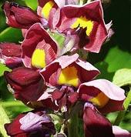 | 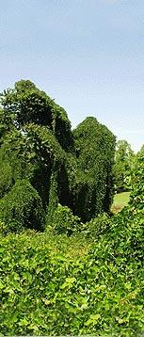
 |  | 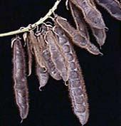

Photos used with permission of Virginia Tech College of Natural Resources and Environment

Japanese Stiltgrass (Microstegium vimineum)
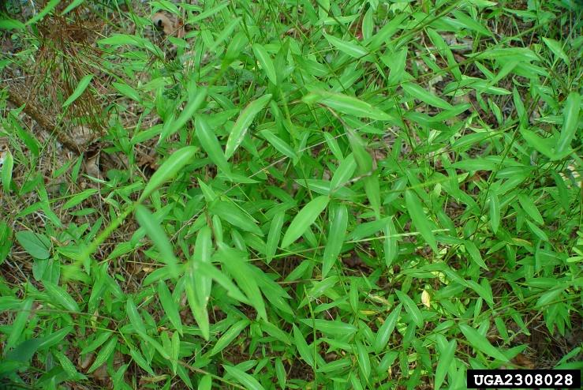
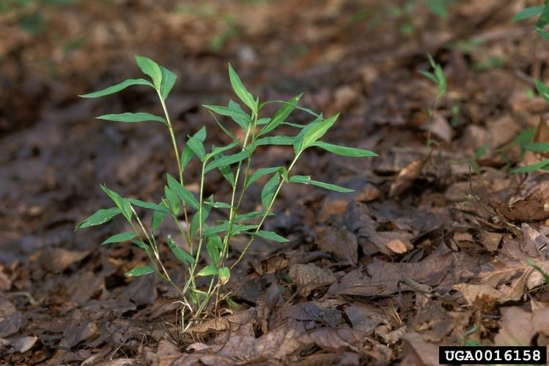

Photo credit: Ted Bodner, So. Weed Science Society, Photo credit: Chuck Bargeron, Univ. of Georgia, bugwood.org bugwood.org

Chinese Privet (Ligustrum sinense)

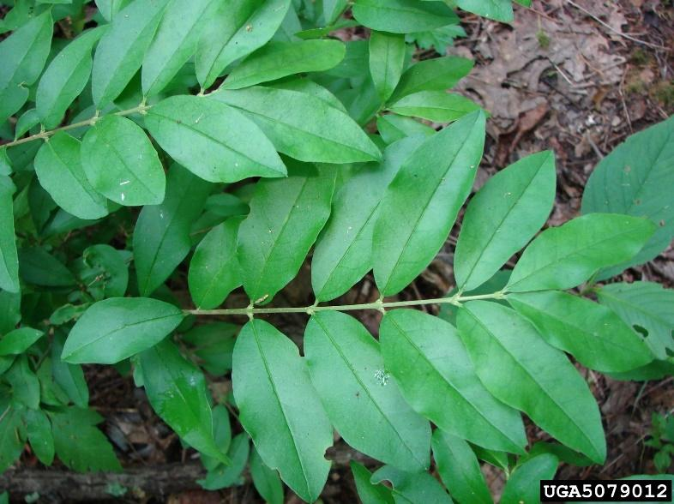
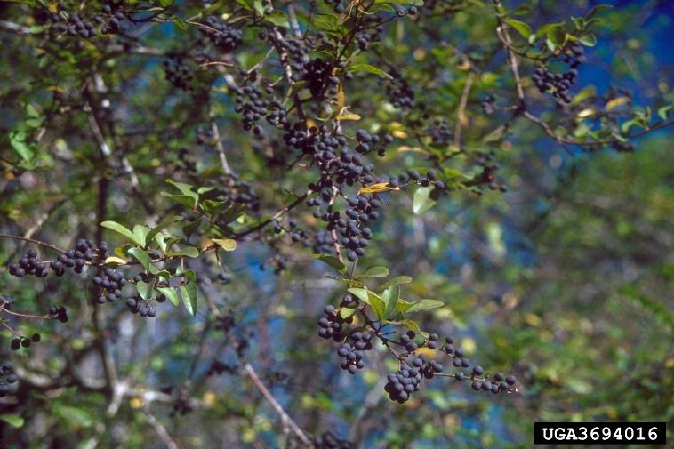
Photo Credit: James R. Allison, Georgia Dept. of Natural Resources, bugwood.org
Photo Credit: Troy Evans, Great Smoky Mountains NP,
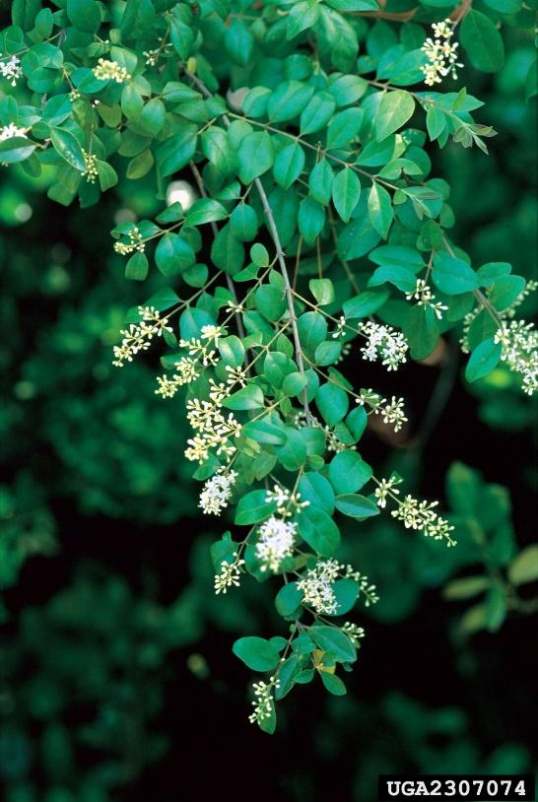
bugwood.org
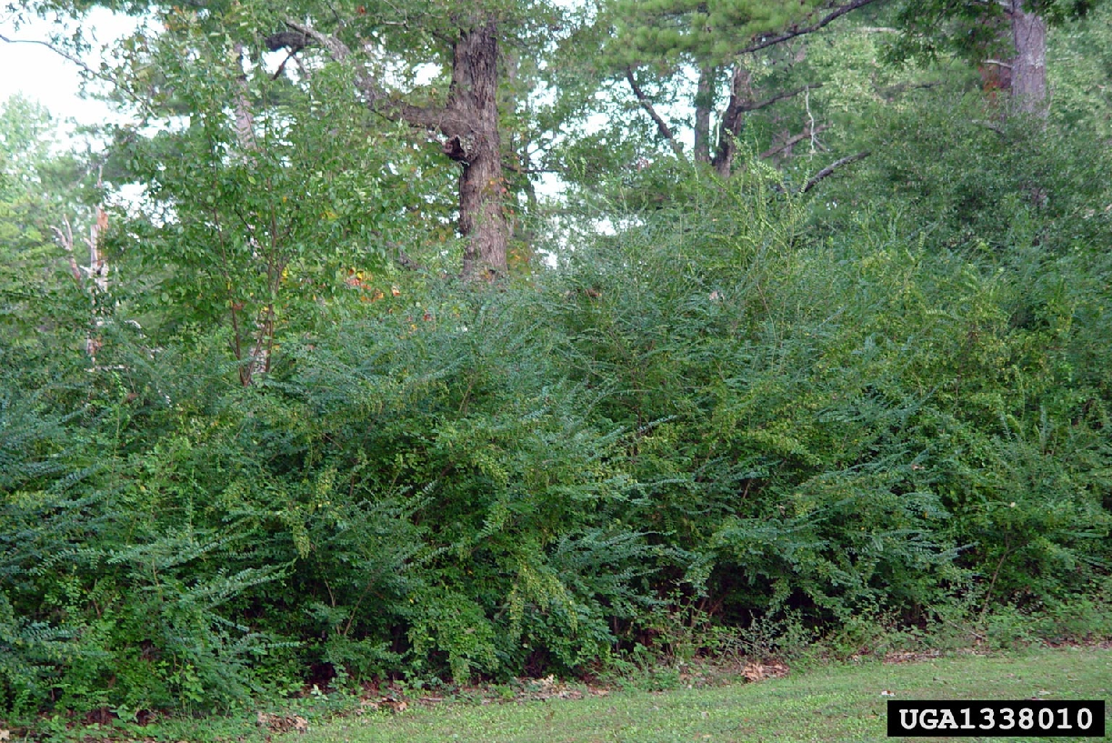
Photo credit: Chris Evans, River to River CWMA,
bugwood.org

Photo credit: Ted Bodner, So. Weed Science
Society,bugwood.org

Garlic Mustard (Alliaria petiolata)
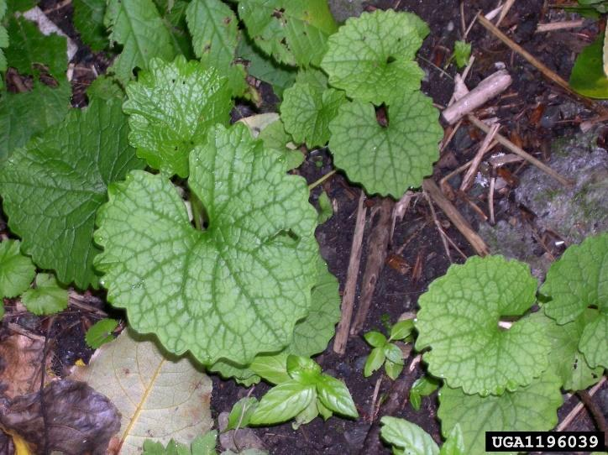
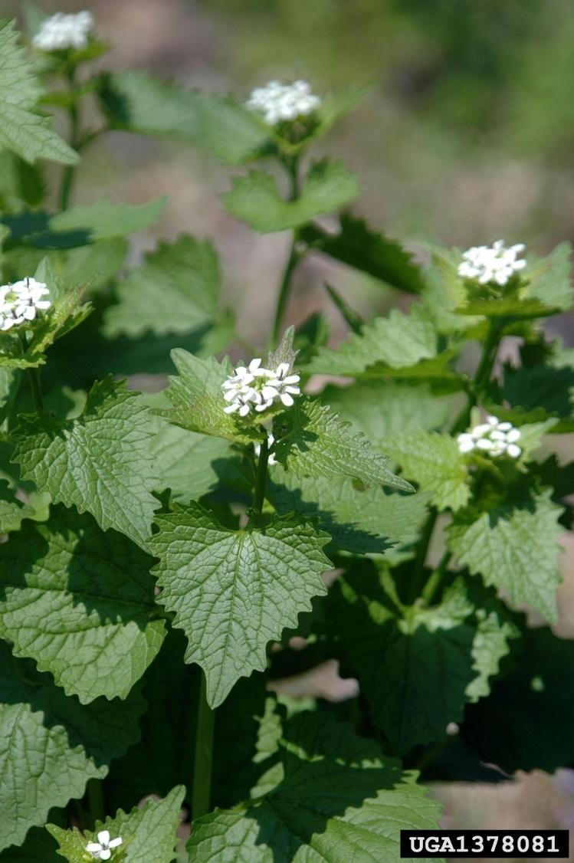

Photo credit: Tom Heulle, USDA Forest Service,
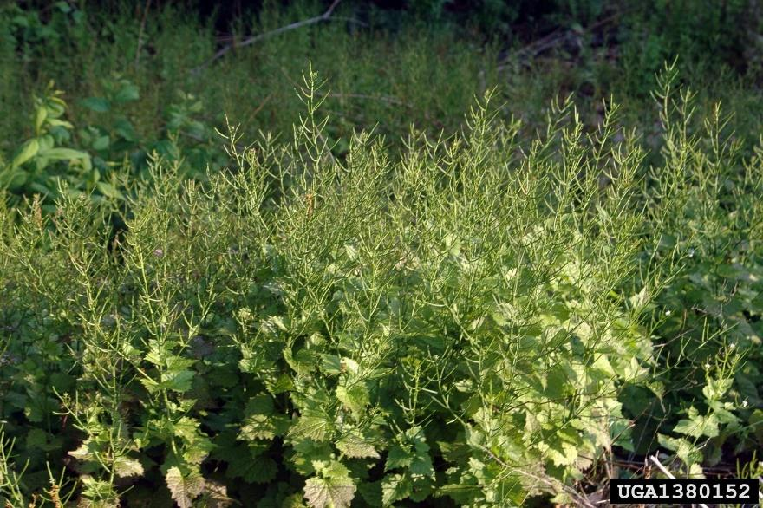
bugwood.org
Photo credits: Chris Evans, River to River CWMA, bugwood.org

