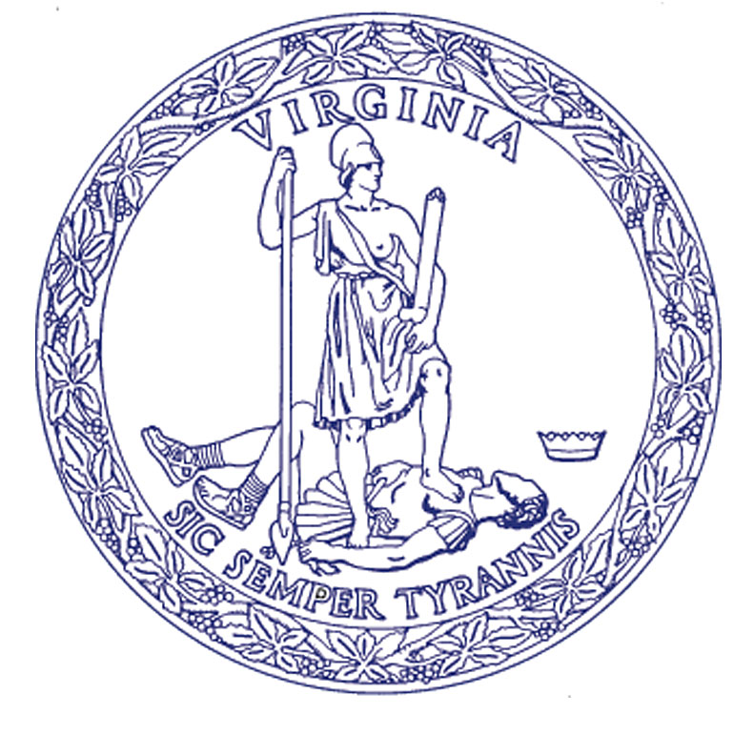
Rob Farrell
State Forester

COMMONWEALTH of VIRGINIA
Department of Forestry
900 Natural Resources Drive, Suite 800 • Charlottesville, Virginia 22903
(434) 977-6555 • Fax: (434) 296-2369 • www.dof.virginia.gov

Formal Hearing
Services Agreement

REFERENCE: Silvicultural Water Quality Law Enforcement
Harvest ID No.: **Harvest ID Number**
Case No.: **Case Number**
Tract No.: **Tract Number**

This Agreement made this **Day** day of **Month**, **Year**, by and between the Virginia Department of Forestry, hereinafter referred to as the Department, and **Name**, Attorney at Law, hereinafter referred to as the Attorney.
The Department requests the following services:
- The Attorney will conduct a Formal Hearing according to the Administrative Process Act in **County** on **Date**.
- The purpose of the Formal Hearing that the Attorney will conduct is to determine if the individuals involved have violated, failed or refused to obey any Special Order (see §10.1-1181.3 of the Code of Virginia).
- The Attorney will provide to the State Forester and the other parties within 30 days from date of Hearing a “Findings of Fact and Conclusion of Law” stating his findings and recommendations. The Attorney will recommend to the State Forester a Civil Penalty amount if appropriate in accordance with §10.1-1181.3 of the Code of Virginia.
- The Attorney will request, and include in the “Findings of Fact and Conclusion of Law,” the Social Security Number(s) of the Owner(s) and Operator(s) with the understanding that this information is not required and that the Owner(s) and Operator(s) have the right to refuse to disclose and that no penalty will be imposed for failure to disclose this information.
- The Department will provide a voice or digital recorder and all necessary equipment to record the Hearing. The recordings will be the property of the Department.
- The Department will pay the Attorney fees as outlined in a memorandum from Robert N. Baldwin, Executive Secretary of the Supreme Court of Virginia, dated June 30, 1995 (see attached copy).
The above is mutually agreed to by all parties.
**Attorney Name** |  |  |  | **Date**
Attorney |  | Signature |  | Date
Bettina K. Ring |  |  |  | **Date**
State Forester |  | Signature |  | Date

