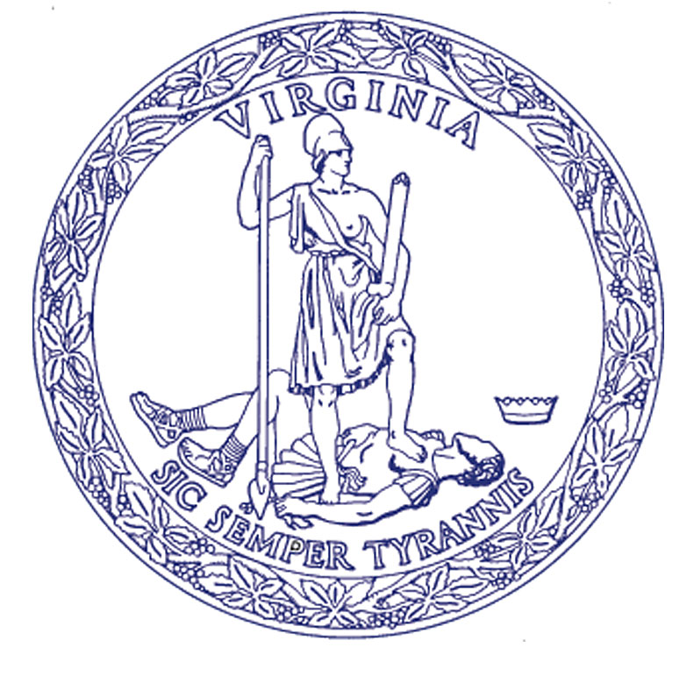
Rob Farrell
State Forester

COMMONWEALTH of VIRGINIA
Department of Forestry
900 Natural Resources Drive, Suite 800 • Charlottesville, Virginia 22903
(434) 977-6555 • Fax: (434) 296-2369 • www.dof.virginia.gov

Harvest Inspection
**Date**
**Name of Landowner/Timber Owner/Operator**
**Address**
**City, State Zip**

REFERENCE: Tract: **Tract Number**

Dear **Name**:
Enclosed is the Harvest Inspection for your recent timber harvest. The Virginia Department of Forestry (DOF) conducts harvest site inspections to ensure that the logging activity has not created any water quality problems. These inspections allow the agency to enforce the water quality laws for which the DOF is responsible.
During this inspection, we also check to make sure that Best Management Practices (BMP’s) were used during the timber harvest. Although not law, BMP’s are guidelines, which are recommended to make sure that minimal disturbance occurs, and that water quality is protected.
Should you have any questions or comments, please feel free to contact your local DOF representative. We appreciate your cooperation and interest in protecting the waters of Virginia.
Sincerely,

**Name**
Forest Warden

